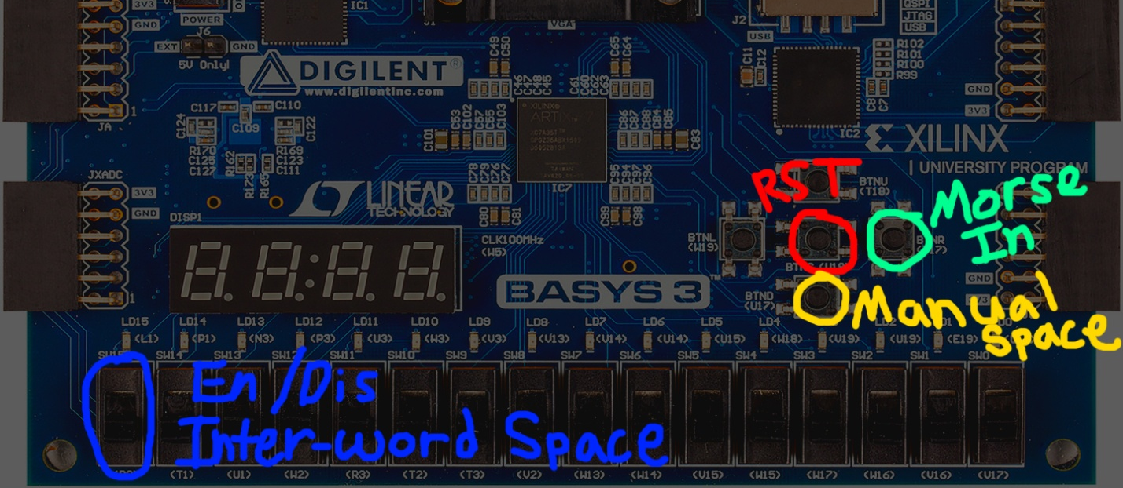
Dit: < 200ms (dit if press time < 200ms)
Dash >= 200ms (dash if press time >= 200ms)
Inter-letter-space 500ms (character is send when not pressed for 500ms
Inter-word-space 1600ms (If Enabled: space if send if not pressed for 1600ms)

Dit: < 200ms (dit if press time < 200ms)
Dash >= 200ms (dash if press time >= 200ms)
Inter-letter-space 500ms (character is send when not pressed for 500ms
Inter-word-space 1600ms (If Enabled: space if send if not pressed for 1600ms)

